Pandas
- 2 types of data
  - DataFrame
  - Series
- Difference between iloc and loc
  - loc使用行和列的标签名进行索引
  - iloc使用行和列的整数位置进行索引
- 数据清洗
  - 缺失值
    - df.info
    - df. isnull () . sum
  - 处理方式
    - Ie: df [ df ['Age'] == None] =0
      - df [ ‘Age’] == None checks the Age column for the none object
      - df [ df ['Age'] == None] This filters the entire DataFrame to isolate only the rows where that condition is true
      - = 0 This sets all values in those matched rows to 0
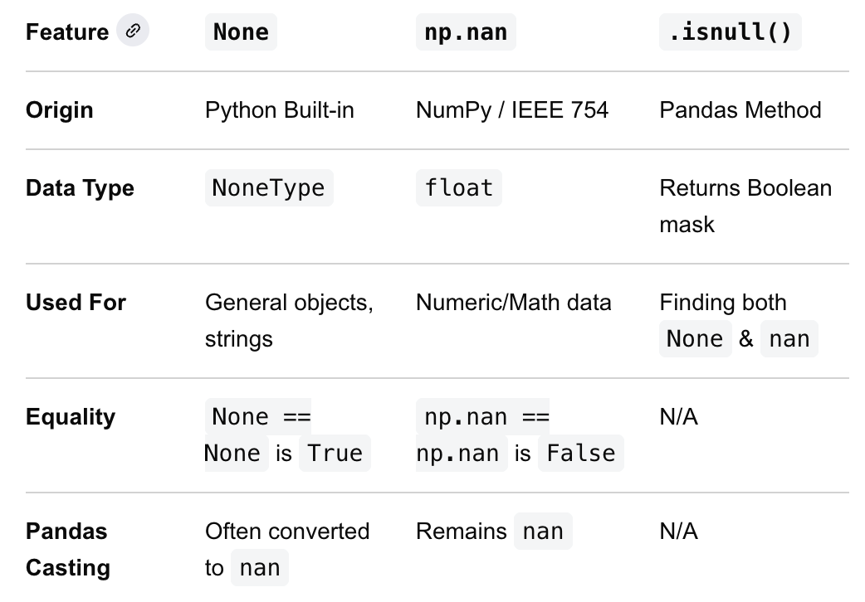

- 文本变量转换
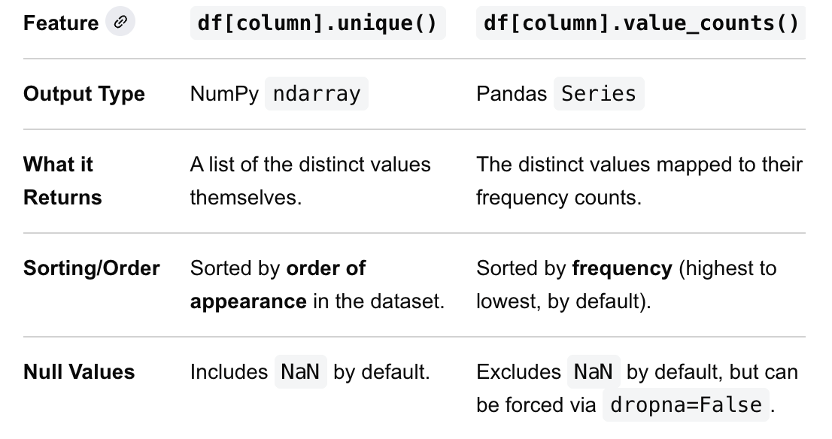

Ie: df['Sex_num'] = df['Sex'].replace(['male','female'],[1,2])
- df['Sex_num']
  - existing text column containing genders
- .replace
  - Swap first list and second lists’ values
